Resources
- Created by Charles Elwood – Bear Den 2012

- Silversides Overnight Website
http://www.silversidesmuseum.org/Overnight-Visits__Camp-on-Silversides-WWII-Sub-Muskegon-Michigan-Sleep-on-Submarine-Scouts-West-Michigan.htm
- Some Reviews from parents
- http://grkids.com/sleeping-on-a-submarine-an-adventure-mom-adventure/
- http://grkids.com/real-us-submarine-open-for-tours-and-overnights/
- http://fox17online.com/2013/03/20/dive-into-the-history-at-muskegon-submarine-museum-this-spring/#axzz2X5MXzM16
- http://www.youtube.com/watch?v=Hsqbkl2KXV8
- Main Costs
  - Event Fees $30 or $35 for each participant (depends on the day of the week)
  - Dinner : Pizza delivered from a local resturaunt
  - Scout Patches : approx. $3
  - Food : Burgers/Brats/Smores and supplies total $91 for 15 people
    - Pack of bottled water
    - 20 burgers – precooked and warmed on firepit – 5 left over
    - 10 brats – preboiled and warmed on fireput – 0 left over
    - 2 large packs of Hersheys
    - 1 box graham crackers
    - 1 bag marshmallows
    - Marshmallow sticks
    - Wet wipes
    - Box of plastic forks
    - Ketchup/mustard
    - Chips/Cheetos
    - Juices/Lemonade
    - Grill Grate with stand – firepits do not have grates
    - Firewood/lighter/paper
    - Paper plates
    - Bag of ice
    - Ice chest
    - Hot dog and hamburger buns
- Packing List
  - Folding chairs for firepit and night watch
  - Sleeping bag
  - Flashlights
  - Pillow
  - PJs
  - Toiletries
  - Cash
  - Uniforms for flag ceremony
  - Cards games
  - Not allowed
    - Pocket knives – museum rules
    - No Nintendo DS – pack rules
    - Pop or food (only water is allowed on the sub)

Before The Event
Most important thing before the event is to inform people about the event, to get a commitment from parents on attendees, to pay deposit, to finalize the list of attendees, and to plan the arrival and return.

- Planning:
  - Dates fill up quickly so book as soon as you can. 1 year prior to event is recommended.
  - Begin right away with last years roster information to see how many parents are interested.
  - Send email to silversides coordinator to block off date and send in deposit check.
  - Pack Leader will sign release form. Scan and Email to the museum event coordinator.
  - 6 weeks before the event, final roster and final payment will be due.
  - The museum is not proactive about getting final payment/roster so I initiated a lot of this myself.
  - There is a medical info form for special conditions, however, nobody in our group had any special medical needs so I didn’t send this in.
  - After this date, I sent out a few planning reminders and itinerary emails to the parents and scouts. Plan carpool.

The Event
Prep:
- On Saturday morning we went to Meijers and purchased all the food items needed and packed the car.
- I boiled the brats for 8 minutes and stuck them in the ice chest. I cooked the burgers on the grill and also stuck them in Tupperware and placed in ice chest.
Car Pool:
- We met at Lakewood elementary school parking lot. 4 cars carpooled from Holland to Muskegon. The trip took about an hour. GPS was helpful since the route through Muskegon was not trivial.
Check in
- Upon Arrival the kids and parents hung out in the playground in front of the museum while I checked in.
- I checked in at the gift shop, about 5:40 pm, which was 20 minutes before they were supposed to be open for us.
- There was one lady who manned the gift shop front desk and three tour guides. Guides were all from local high schools.
- They found my file, gave me certificates of participation for each scout and talked through the plans for the night.
- There were three groups that night. Two cub scout groups sleeping on the submarine and one boy scout group sleeping on the ship.
- We decided to eat first while the other groups took tours. We were also the only group that participated in the flag ceremony. Since it was around 6:30 pm at this time, I recommend eating first since the kids were getting pretty hungry. The tour guides were reluctant to let us eat first, but once I told them I had precooked the food, they agreed. They also told me they don’t like leaving the fire running and unattended so we put the fire while we took the tour.
- Once I received certificates and understood the plan, I went back out to the parking lot, gathered the troops and moved to the fire pits.
Dinner:
- There were two fire pits at the facility, both behind the museum along the channel for boats to get out to lake Michigan.
- We first chose to use the firepit next to the submarine, but the view was obstructed by another boat under repair.
- Dinner on the firepit turned out to be a bunch of fun and is highly recommended. The grate with stands from Meijers worked out really well, and everyone appreciated that the food was quickly heated up and ready to eat almost immediately. I probably should have bought 5 more brats.
- Note : The kids played on the hill next to the firepits, but I found out later that there is a house just behind the hill.
Flag Ceremony
- After dinner, one of the tour guides had us meet at the front of the museum where there were flags of each of the branches of the military.
- The guide had two scouts stationed at each flagpole and had one parent at each flagpole.
- He had us start lowering the Navy flag to initiate the ceremony, but then each of the flags had to come down at the same rates since “no branch of the military was more important than any other branch”. Then we folded the flags and handed them to the tour guide.
- He then walked us out to the American flag at the front of the parking lot.
- He lowered the flag and had the scouts catch and keep the flag off the ground and then we folded the flag in triangles.
Tour of the Sub
- Next we took a guided tour of the sub.
- Tour guide took us on the deck, then through the torpedo bays, the captains quarters, the mess hall, the kitchen, the engine room, and the control rooms and then back through the back torpedo bays.
Smores / Self Guided Museum Tour
- Next, the sub was ready for loading. Instead of battling the other group while they loaded, we decided to make smores and tour the museum before loading.
- We moved our fire to the second fire pit so that we could see the sunset and also see the boats passing by in the channel. Smores were a big hit with the kids as always.
- We then headed into the museum building and did a self guided tour.
- Some highlights are the
  - Cross sectioned torpedo in the front room.
  - The working periscope in the middle of the exhibit floor
  - Gift Shop
    - Some kids bought:
      - Rubber bracelets that said Silversides
      - Tshirts with museum logo
      - Bag of rocks
    - Pack bought patches that said I slept overnight on the USS Silversides.
Loading:
- Next we loaded our sleeping bags and bags onto the sub.
- Its good to remind the kids at this point to not run and to not touch/turn knobs on the sub. Most of the systems on this sub are still operational and the museum warns the kids not to touch anything.
- Folding chairs were setup on the deck.
- Some kids went into officers quarters and played chess.
- Some kids joined me on the upper deck to watch the Stanley Cup playoffs on my cellphone. Note: cell reception in museum and in the sub are non existent.
- Pack Leader had an all hands meeting at this point to remind kids of rules and upcoming events.
- I had parents sign up for night watch at this point. I had 3 slots of two hours with two parents and 1 slot of 2 hour during the final shift.
- Kids took the bunks in the torpedo room and the parents took the bunks in the captains quarters.

Bedtime
- Lights out was supposed to be at 11 PM but nobody from the museum really enforce that.
- The museum and store closed at 11 pm and the tour guides went home at this point. A night watch person was at the museum’s front office but all doors were locked, so you had to knock on the front door to get his attention. There were bathrooms open at the side of the building. The store opened up again at 8 AM the next day.
- All the kids went to the bathroom around 11 PM prior to lights out.
- Around 11:30 pm, after much shuffling, the kids were tucked into their bunks.
- Most kids were asleep by midnight. Some claimed they were up till 2 AM.
- Note : ear plugs are very useful as some parents may snore and some kids may continue to be loud.
- Also, the temp did cool down. The front torpedo room cooled off nicely but the back of the captains quarters stayed warm for a longer time.
- Most of the parents had a pow wow in lawn chairs up on the deck but the parents that had graveyard shift nightwatches went to bed earlier.
Nightwatch
- The purpose of the nightwatch is to make sure kids don’t wake up needing to go to the bathroom and walk off the boat by themselves during the night.
- Since Cub Scouts have a 2 deep rule, the schedule included 2 parents on the watch for 2 hour shifts.
- If weather is bad, there is a room in the captains quarters where the parents can sit. The group on the Mcclane ship held their watch on the firepit on shore. The parents with the other cub scout group on the sub held their watch on the bleachers in front of the museum.

After The Event
Breakfast
- After waking up, we went to the bathrooms, freshened up, and unloaded the sub.
- One of the parents did a final walk through and found a pillow and tshirt so a final walkthrough is important.
- There are no planned activities in the morning, so we were able to leave when we wanted. I think the museum wanted everybody off the sub by 9:30 AM.
- There was a pot of free coffee for the parents in the museum.
- We drove back to Sherman road and stopped for breakfast at Mcdonalds.

Comments/Tips/Notes:
- Precooking the food was key in getting food to hungry parents and kids quickly.
- The plans are “free format” and negotiated with the store attendant when you arrive. Just work with the store attendant to schedule you dinner, your flag ceremony, your tour and loading of the sub.
- I made sure the kids understood that there was no running in the museum and on shore next to the lake. I also reminded everyone that this was a museum and no running/hide and seek or playing with the sub equipment was allowed.
- There was a class to build a submarine/robot in the museum building but based on recommendations from another scout leader, I didn’t sign our group up for the class.
- I waited too late to collect money for the trip. Bill recommended taking a down payment of $10 early in the year and collect remainder about 2 months prior to the trip itself.
- They had air conditioning for the sub but didn’t seem to want to turn it on so be aware that the air can be stuffy the further away you get from the hatch. Air did flow in from the hatch and provided a nice breeze.

Pictures
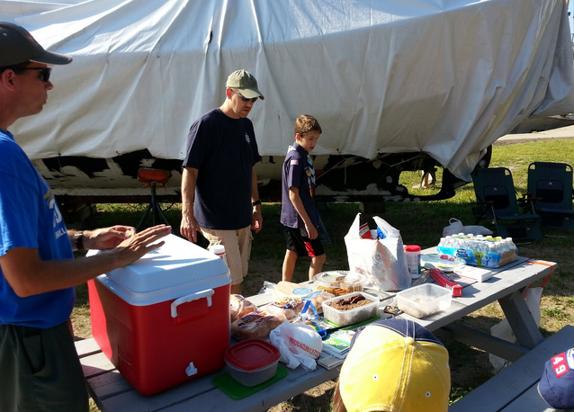
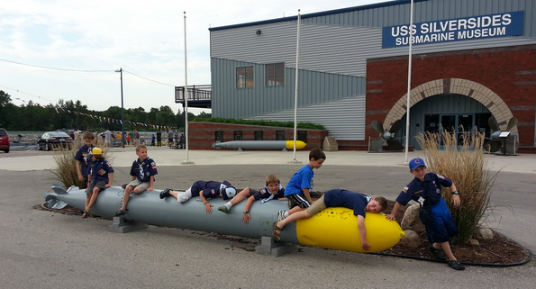
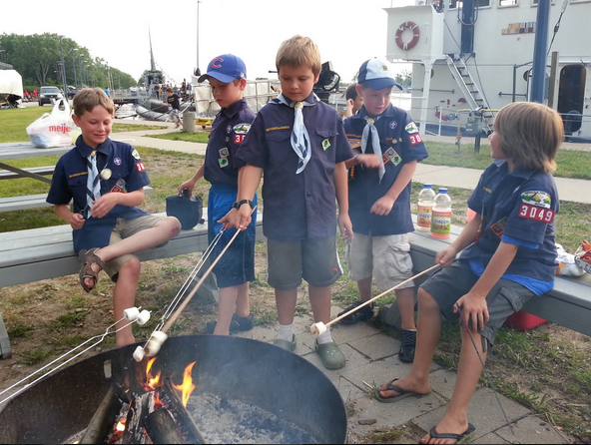
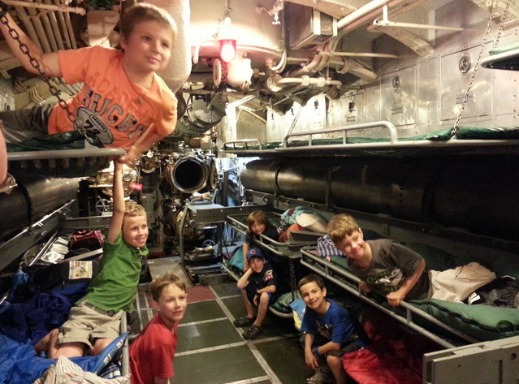

Appendix

2013 itinerary

Notes from Bull Bush – Leader that took a den in 2012

Here is what I have from the trip. One was the flyer I gave out to the parents. The other is a spreadsheet I used to track who paid, etc. The second sheet is a night watch time slot. You'll need to have an adult up for your group all night. I had the parents sign up for a slot when we got there. The third sheet is a list of notes I had right after the trip. One thing I recall being an option was to have the boys participate in a kind of robotic boat build. Another group of older kids was doing it when we arrived. I thought it might be a bit much for 3rd graders when I saw it, so I was glad we didn't pay extra to do it.
Go ahead and pick a date quickly and call them to reserve it. I went to make a reservation at this time of year and the first available date was the first weekend in June. It can get warm on board the boat, no A/C or air movement, so if you can snag a date in May, that might be better. Friday night seemed to work well.
Let me know if you have any questions about logistics or what our group did up there. Your contact at the museum can answer a lot of questions, too.

Information Documents from the Silversides Website :

- Rules Document
- Program Timeline
- What to bring and not bring

Email I sent prior to trip:

Hello Submariner Scouts…

Reminder that the USS Silversides event is coming up on June 22nd.

Attendees:
Alex Spilotro - riding
Josh/Charles Elwood - driving
Jaysen/Alan Hoezee -
Gabe/Dale Hoberman -
Ryan/Chad Mitchem -
Conner /Jay Nienhuis -
Derek/Jim Piersko -
Sean/Joe Dummer -

Note : Please let me know if you plan on driving and if you can accommodate passengers
So far, nobody has confirmed if they are driving or riding.
I am bringing Josh and Alex and have room for a parent/son pair in my car. Let me know if you are riding or driving.

Timeline for travel:
1) Meet in Lakewood Elementary Parking Lot at 4:30 pm on June 22nd
2) Carpool to Museum - approx 1 hour drive
Address: 1346 Bluff St, Muskegon, MI 49441
Phone:(231) 755-1230
3) Leave Silversides Museum to head back to Holland 9:40 AM on June 23rd
4) Arrive at Lakewood Elementary parking lot

Checkin is at 6 pm
I will bring burgers, brats and smore's supplies.
Does anybody have any food restrictions?
Does anybody have firewood they could bring?
Wear uniforms for flag ceremony.
Parents will sign up for a watch. 3 two hour watches with two parents and 1 one hour watch with 1 parent. Scouts are welcome to join the watch.
Medical Condition form is at the following link, for anybody that needs to make the museum aware of a medical condition.
http://www.silversidesmuseum.org/pdfs/Medical%2520Condition%2520Form.pdf

Basic List of things to bring:
Sleeping bag, sheet, pillow
flashlight
toiletries
cards/board games
money for souvenirs
camera/film
(no knives, no gum, no air mattresses, no tents, no roller sneakers)
Sample Timeline, Rules and Packing List are attached.

Paul,
I need a check for Alex S. made out to "Pack 3049". Please get the check to Chad.

Email from Silversides Organizer

I wanted to get back to you with answers to the questions you sent us. Hopefully I get them all, but if I miss one, please feel free to let me know. It is fine if you want to scan and email the release form and the roster. As far as the medical forms, I only need them filled out for people staying with us that have a medical information. I do not need a stack of them all saying everybody is fine.

We do have another group staying on the sub with your group and a different group spending the night on the cutter, so I feel confident that the minimum of 20 people staying with us should be no problem. We have two fire pits on property, so they would be shared between the three groups staying here with us.

I did speak with our head maintenance person, and he did not think fans aboard the sub would be a great idea, but he did want me to let you know that it is air-conditioned if the temperature goes too high for comfort, and some of the windows can be opened.

There are no working bathrooms on the submarine, so anybody needing to use one would need to go to our main building, but it is a pretty short walk between the two, so hopefully that will not be a problem for you.

And finally, there is a DVD player on the sub that you can use to help quiet them down in the evening if needed. I will let our staff know if that is going to be your plan so they can do their best to arrange your group for the best viewing for that.

I think I got all of the questions, but like I said, if I missed anything or something else comes up for you, please feel to just ask! Otherwise you can send us your final count and payment, and we’ll look forward to hosting your group here in June

